LAPORAN PRAKTIKUM
Aplikasi Berbasis Platform

MODUL 7


Disusun oleh:
NAUFAL GERALDO PUTRA P.
2311102154
S1 IF-11-04

Dosen Pengampu:
Cahyo Prihantoro, S.Kom., M.Eng

PROGRAM STUDI S1 INFORMATIKA
FAKULTAS INFORMATIKA
INSTITUT TEKNOLOGI TELKOM PURWOKERTO
2026/2027
LINK GITHUB PRIBADI: https://github.com/NGZ101/Praktikum-APB
LINK GITHUB KELAS: https://github.com/Aplikasi-Berbasis-Platform-S1IF-11-04/Pertemuan-11-Mobile.git
Soal
Untuk tugas sendiri kalian baca aja modul 7 , dan buat route qtau navigasi dari sources code yang di kasih kemaren ( 6 sampai 7 halaman) , terus tambahkan notifikasi. Untuk bentuk notifikasinya bebas, bisa pas perpindahan halamnanya atau pas masukan datanya

Jawaban

- Code Main
Berikut code yang mengontrol navigation bar dan notification.
import 'package:flutter/material.dart';
import 'screens/button.dart';
import 'screens/container.dart';
import 'screens/flutter1.dart';
import 'screens/rowdancollom.dart';
import 'screens/tessting.dart';
import 'screens/textfield.dart';

void main() {
runApp(const MyApp());
}

class MyApp extends StatelessWidget {
const MyApp({super.key});

// This widget is the root of your application.
@override
Widget build(BuildContext context) {
return MaterialApp(
debugShowCheckedModeBanner: false,
title: 'Flutter Demo',
theme: ThemeData(colorScheme: .fromSeed(seedColor: Colors.blue)),
home: const MyHomePage(title: 'Modul 7 - Pertemuan 12'),
);
}
}

class MyHomePage extends StatefulWidget {
const MyHomePage({super.key, required this.title});
final String title;

@override
State<MyHomePage> createState() => _MyHomePageState();
}

class _MyHomePageState extends State<MyHomePage> {
int _indexNow = 0;
void _onItemTapped(int index) {
setState(() {
_indexNow = index;
});

final List<String> labels = [
'Button',
'Container',
'My App',
'Row Dan Column',
'Testing',
'Textfield',
];

ScaffoldMessenger.of(context).clearSnackBars();
ScaffoldMessenger.of(context).showSnackBar(
SnackBar(
content: Text('Berhasil ke halaman ${labels[index]}'),
backgroundColor: Colors.green,
duration: const Duration(
milliseconds: 800,
),
),
);
}

@override
Widget build(BuildContext context) {
final List<Widget> screens = [
Button1(),
Container1(),
Myapp1(),
Rowdancollom1(),
Tessting1(),
Textfield1(),
];
return Scaffold(
appBar: AppBar(
backgroundColor: Theme.of(context).colorScheme.inversePrimary,
title: Text(widget.title),
),
body: screens[_indexNow],
bottomNavigationBar: BottomNavigationBar(
currentIndex: _indexNow,
onTap: _onItemTapped,
type: BottomNavigationBarType.fixed,
items: const [
BottomNavigationBarItem(
icon: Icon(Icons.smart_button),
label: 'Button',
),
BottomNavigationBarItem(icon: Icon(Icons.square), label: 'Container'),
BottomNavigationBarItem(
icon: Icon(Icons.app_shortcut_outlined),
label: 'My App',
),
BottomNavigationBarItem(
icon: Icon(Icons.grid_3x3),
label: 'Row Dan Collumn',
),
BottomNavigationBarItem(
icon: Icon(Icons.developer_mode),
label: 'Testing',
),
BottomNavigationBarItem(
icon: Icon(Icons.text_fields),
label: 'Textfield',
),
],
),
);
}
}

- Code button.dart
Berikut adalah halaman berisi tombol dengan text “login”.
import 'package:flutter/material.dart';

class Button1 extends StatelessWidget {
@override
Widget build(BuildContext context) {
return MaterialApp(
debugShowCheckedModeBanner: false,
home: Scaffold(
appBar:AppBar(title: Text("ini aplikasi saya ")) ,
body: Center(child:
OutlinedButton(
onPressed: (){
print("button di tekan ");

},
style: OutlinedButton.styleFrom(
backgroundColor: Colors.amberAccent
),
child: new Text("login")
),),
),
);
}

}
Berikut Hasil Navigasi dan Notifikasi:
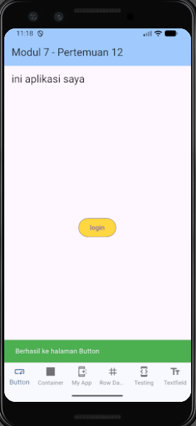
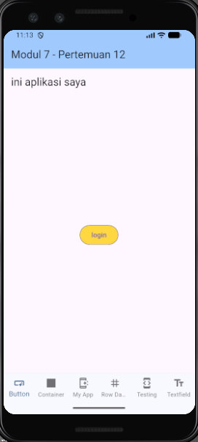

- Code Container.dart
Berikut adalah halaman berisi container berwarna merah dengan border bawah dan kiri berwarna black12 serta border kanan berwarna deepPurpleAccent yang memiliki teks “belajar container”.
import 'package:flutter/material.dart';

class Container1 extends StatelessWidget {
@override
Widget build(BuildContext context) {
return MaterialApp(
debugShowCheckedModeBanner: false,
home: Scaffold(
appBar:AppBar(title: Text("ini aplikasi saya ")) ,
body: Container(
padding: EdgeInsets.symmetric(vertical: 20, horizontal: 30),
decoration: BoxDecoration(
color: Colors.red,
border: Border(
bottom: BorderSide(width: 3,color: Colors.black12),
left: BorderSide(width: 3,color: Colors.black12),
right: BorderSide(width: 3, color: Colors.deepPurpleAccent),
top: BorderSide(width: 3, color: Colors.teal)

)
),
child: Center(child: Text("belajar container"),),
//height: 200,
//width: 200,
width: double.infinity,
height: 100,
),
),
);
}

}
Berikut Hasil Navigasi dan Notifikasi:

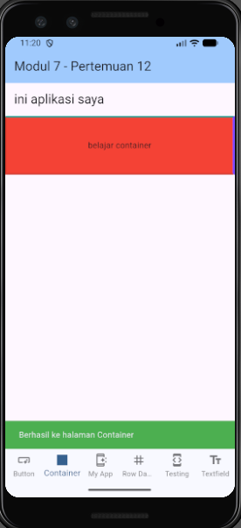
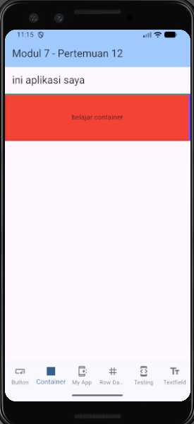

- Code Flutter1.dart
Berikut adalah halaman berisi title: “ini aplikasi saya” dan body: “ini data saya”.
import 'package:flutter/material.dart';

class Myapp1 extends StatelessWidget {
@override
Widget build(BuildContext context) {
return MaterialApp(
debugShowCheckedModeBanner: false,
home: Scaffold(
appBar:AppBar(title: Text("ini aplikasi saya ")) ,
body: Text("ini data saya "),
),);
}

}
Berikut Hasil Navigasi dan Notifikasi:
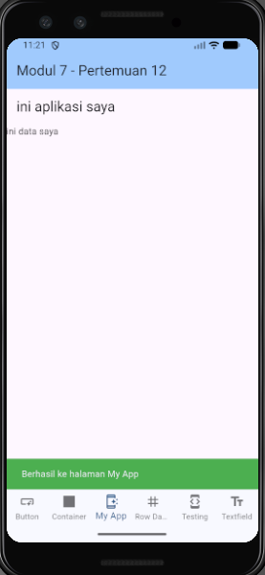
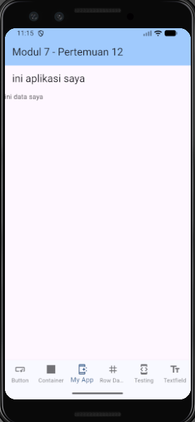

- Code Rowdancollom.dart
Berikut adalah halaman berisi 2 text field untuk login, satu untuk memasukkan username dan satu untuk memasukkan password yang menyembunyikan input user serta Elevated Button dengan text: “data”.
import 'package:flutter/material.dart';

class Rowdancollom1 extends StatelessWidget {
@override
Widget build(BuildContext context) {
return MaterialApp(
debugShowCheckedModeBanner: false,
home: Scaffold(
appBar:AppBar(title:
Text("login ")) ,
body: Column(
children: [
Text("FROM LOGIN"),
Padding(
padding:EdgeInsets.all(20) ,
child: TextField( decoration: InputDecoration(
border: OutlineInputBorder(),
hintText: "silahkan masukan username"
),
),
),
Padding(
padding:EdgeInsets.all(20) ,
child: TextField(
obscureText: true,
decoration: InputDecoration(
border: OutlineInputBorder(),
hintText: "silahkan masukan password"
)),
),

ElevatedButton(onPressed: (){} ,child: Text("data")),

],
),

),
);
}

}
Berikut Hasil Navigasi dan Notifikasi:
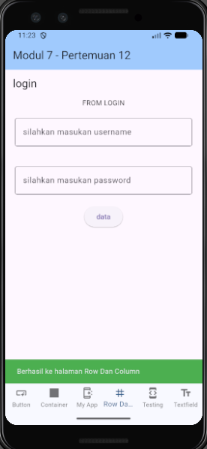
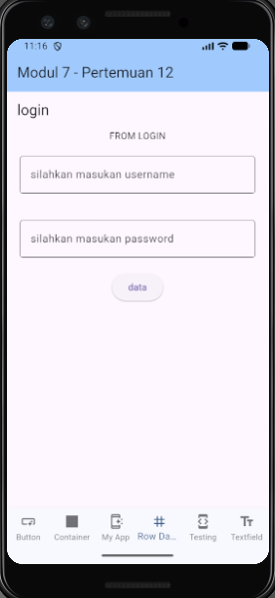

- Code Tessting.dart
Berikut adalah halaman berisi code aplikasi default flutter.
import 'package:flutter/material.dart';

class Tessting1 extends StatelessWidget {
const Tessting1({super.key});

// This widget is the root of your application.
@override
Widget build(BuildContext context) {
return MaterialApp(
title: 'Flutter Demo',
theme: ThemeData(
// This is the theme of your application.
//
// TRY THIS: Try running your application with "flutter run". You'll see
// the application has a purple toolbar. Then, without quitting the app,
// try changing the seedColor in the colorScheme below to Colors.green
// and then invoke "hot reload" (save your changes or press the "hot
// reload" button in a Flutter-supported IDE, or press "r" if you used
// the command line to start the app).
//
// Notice that the counter didn't reset back to zero; the application
// state is not lost during the reload. To reset the state, use hot
// restart instead.
//
// This works for code too, not just values: Most code changes can be
// tested with just a hot reload.
colorScheme: .fromSeed(seedColor: Colors.deepPurple),
),
home: const MyHomePage(title: 'Flutter Demo Home Page'),
);
}
}

class MyHomePage extends StatefulWidget {
const MyHomePage({super.key, required this.title});

// This widget is the home page of your application. It is stateful, meaning
// that it has a State object (defined below) that contains fields that affect
// how it looks.

// This class is the configuration for the state. It holds the values (in this
// case the title) provided by the parent (in this case the App widget) and
// used by the build method of the State. Fields in a Widget subclass are
// always marked "final".

final String title;

@override
State<MyHomePage> createState() => _MyHomePageState();
}

class _MyHomePageState extends State<MyHomePage> {
int _counter = 0;

void _incrementCounter() {
setState(() {
// This call to setState tells the Flutter framework that something has
// changed in this State, which causes it to rerun the build method below
// so that the display can reflect the updated values. If we changed
// _counter without calling setState(), then the build method would not be
// called again, and so nothing would appear to happen.
_counter++;
});
}

@override
Widget build(BuildContext context) {
// This method is rerun every time setState is called, for instance as done
// by the _incrementCounter method above.
//
// The Flutter framework has been optimized to make rerunning build methods
// fast, so that you can just rebuild anything that needs updating rather
// than having to individually change instances of widgets.
return Scaffold(
appBar: AppBar(
// TRY THIS: Try changing the color here to a specific color (to
// Colors.amber, perhaps?) and trigger a hot reload to see the AppBar
// change color while the other colors stay the same.
backgroundColor: Theme.of(context).colorScheme.inversePrimary,
// Here we take the value from the MyHomePage object that was created by
// the App.build method, and use it to set our appbar title.
title: Text(widget.title),
),
body: Center(
// Center is a layout widget. It takes a single child and positions it
// in the middle of the parent.
child: Column(
// Column is also a layout widget. It takes a list of children and
// arranges them vertically. By default, it sizes itself to fit its
// children horizontally, and tries to be as tall as its parent.
//
// Column has various properties to control how it sizes itself and
// how it positions its children. Here we use mainAxisAlignment to
// center the children vertically; the main axis here is the vertical
// axis because Columns are vertical (the cross axis would be
// horizontal).
//
// TRY THIS: Invoke "debug painting" (choose the "Toggle Debug Paint"
// action in the IDE, or press "p" in the console), to see the
// wireframe for each widget.
mainAxisAlignment: .center,
children: [
const Text('You have pushed the button this many times:'),
Text(
'$_counter',
style: Theme.of(context).textTheme.headlineMedium,
),
],
),
),
floatingActionButton: FloatingActionButton(
onPressed: _incrementCounter,
tooltip: 'Increment',
child: const Icon(Icons.add),
),
);
}
}
Berikut Hasil Navigasi dan Notifikasi:
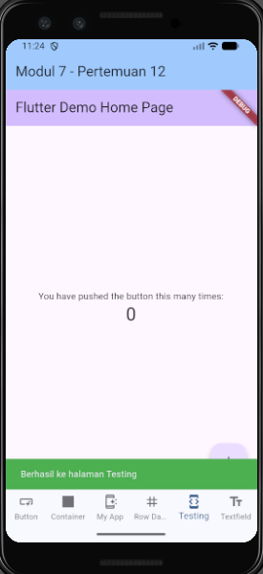
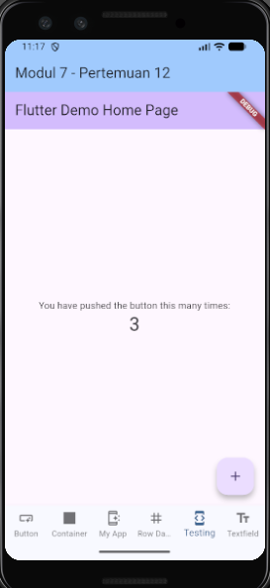

- Code Textfield.dart
Berikut adalah halaman berisi textfield berwarna biru dengan icon supervisor_account, border radius 40 sehingga sudut terlihat bulat, dan hintText: "silahkan masukan user name ".
import 'package:flutter/material.dart';

class Textfield1 extends StatelessWidget {
@override
Widget build(BuildContext context) {
return MaterialApp(
debugShowCheckedModeBanner: false,
home: Scaffold(
appBar:AppBar(title: Text("ini aplikasi saya ")) ,
body: TextField(
maxLength: 20,
decoration: InputDecoration(
border: new OutlineInputBorder(
borderRadius: new BorderRadius.circular(40),
borderSide: BorderSide(color: Colors.green)
),
filled: true,
fillColor: Colors.blue,
labelText: "username",
hintText: "silahkan masukan user name ",
helperText: "masukan hanya 20 karakter",
prefixIcon: Icon(Icons.supervisor_account)
),
),

),);
}

}
Berikut Hasil Navigasi dan Notifikasi:

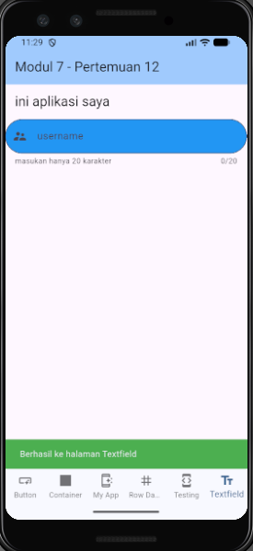
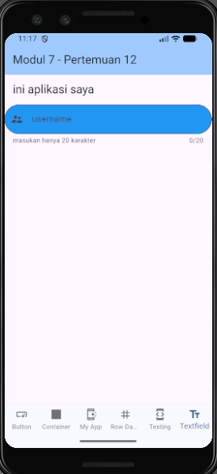

PENJELASAN
Aplikasi ini mengimplementasikan komponen Bottom Navigation Bar dengan memanfaatkan state indeks aktif (_indexNow) untuk mengatur perpindahan halaman. Melalui sinkronisasi indeks tersebut dengan BottomNavigationBarItem, user dapat menjelajahi enam halaman berbeda yang telah disusun secara modular di dalam folder screens.
Aplikasi ini juga menggunakan notifikasi (ScaffoldMessenger.of(context).showSnackBar) yang memberi tahu user bahwa mereka berhasil ke halaman tertentu bedasarkan index halaman sekarang dan final List<String> label yang diberikan setiap halaman (content: Text('Berhasil ke halaman ${labels[index]}')).

